SIMATS ENGINEERING (SAVEETHA SCHOOL OF ENGINEERING)
Department of Artificial Intelligence and Data Science
ASSESSMENT TOOL 1 – Experiments

Course Code: | DSA03 | Course Title: | Natural Language Processing
CO Assessed: | CO3 – Precision | Assessment: | Assessment Tool 1 – Experiments
Weightage: | 50% of CIA
CO5 Statement: | Apply N-gram models, smoothing techniques, part-of-speech tagging systems and to evaluate effective syntactic analysis. (BL-3)
Student Name: | C.Ishwarya | Reg. No.: | 192472108
Section / Batch: | CSE-AI | Date:

Code of Conduct
I _C.Ishwarya(192472108)_______________ (Name / Reg No) certify that this submission is my original work and that I have adhered to the guidelines specified for this assessment. I understand that any violation of academic integrity rules will result in disciplinary action.
Signature of the Student: ____Ishwarya_____________________

Instructions
- Perform all experiments using Google Colab.
- Create a separate notebook (.ipynb) for the assessment.
- Ensure all code is executable without errors.
- Include appropriate comments explaining the logic used.
- Complete all three experiments in a single Google Colab notebook.
- Execute all cells and display the outputs for the given test cases.
- Save the notebook with the naming convention: RegNo_Name_CO3-AT1.ipynb
- Upload the notebook to your GitHub repository.
- Ensure the repository is public or accessible to the instructor.
- Submit the following:
- GitHub Repository Link in GCR
- Google Colab Share Link in GCR
- Screenshots of uploaded coding and output files as printout.
- Duration: 30 minutes.

Section / Topic | Focus |  | Experiment Questions
Context-Free Grammars for English Syntax, Context-Free Rules and Trees, Sentence-Level Constructions, Parsing, Top-Down Parsing, Earley Parsing |  | Design a Python program to validate sentences using CFG production rules and construct parse tree representations for valid sentences. | Q1
Agreement, Feature Structures, Sub Categorization |  | Design a Python program to verify subject–verb agreement and validate grammatical constraints using feature structures and subcategorization rules. | Q2
Probabilistic Context-Free Grammars (PCFGs) |  | Design a Python program to parse sentences and compute sentence probabilities using probabilistic grammar production rules. | Q3

Annexure A – Experiments

Experiment 1: Context-Free Grammar Rule Validation and Parse Tree Construction

Experiment Description
Design a Python program to validate whether a sentence follows the given Context-Free Grammar (CFG) rules and generate its parse tree representation.
Grammar:
S → NP VP
NP → Det N
VP → V NP
Det → the | a
N → student | teacher | book
V → reads | likes

Task
- Accept a sentence as input.
- Verify whether it conforms to the CFG.
- Construct and return the parse tree.
- Return "Invalid Sentence" if parsing fails.

Function Prototype
def parse_cfg(sentence):
pass

Test Cases
Input | Expected Output
the student reads a book | Valid Parse Tree
a teacher likes the book | Valid Parse Tree
student reads book | Invalid Sentence
the book likes a teacher | Valid Parse Tree
reads the student book | Invalid Sentence

Experiment 2: Agreement and Feature Structure Checking

Experiment Description
Design a Python program that verifies subject–verb agreement using feature structures containing Number and Person attributes.

Feature Rules
he → singular, third person
she → singular, third person
it → singular, third person
they → plural
runs → singular verb
writes → singular verb
run → plural verb
write → plural verb

Task
- Accept Subject and Verb.
- Compare feature structures.
- Return True if agreement holds.
- Return False otherwise.

Function Prototype
def check_agreement(subject, verb):
pass

Test Cases
Subject | Verb | Expected
he | runs | True
he | run | False
they | run | True
they | writes | False
she | writes | True

Experiment 3: Probabilistic Context-Free Grammar (PCFG) Parsing

Experiment Description
Implement a Python program to compute the probability of a sentence using the given PCFG.

Grammar
S → NP VP [1.0]
NP → John [0.6]
NP → Mary [0.4]
VP → runs [0.5]
VP → walks [0.5]

Probability Formula
P(Sentence)
=
P(S→NP VP)
× P(NP)
× P(VP)

Task
- Accept a two-word sentence.
- Parse using the PCFG.
- Compute sentence probability.
- Return 0 if sentence cannot be generated.

Function Prototype
def sentence_probability(sentence):
pass

Test Cases
Input Sentence | Expected Probability
John runs | 0.30
John walks | 0.30
Mary runs | 0.20
Mary walks | 0.20
Peter runs | 0.00

Experiment 1
Aim
To design a Python program that validates an English sentence using Context-Free Grammar (CFG) production rules and constructs a parse tree for valid sentences.
Grammar
S → NP VP
NP → Det N
VP → V NP

Det → the | a
N → student | teacher | book
V → reads | likes
Algorithm
- Accept a sentence as input.
- Convert the sentence into a list of words.
- Define CFG production rules.
- Check whether the first two words form a valid NP.
- Check whether the remaining words form a valid VP.
- A valid VP must contain:
  - Verb
  - Noun Phrase
- Construct the parse tree if all rules are satisfied.
- Return Invalid Sentence if any rule fails.
Python Code:
# Experiment 1:
# Context-Free Grammar Rule Validation and Parse Tree Construction

# Define CFG vocabulary
DETERMINERS = {"the", "a"}
NOUNS = {"student", "teacher", "book"}
VERBS = {"reads", "likes"}

def parse_cfg(sentence):
"""
Validates a sentence using the given CFG
and constructs a parse tree for valid sentences.

Grammar:
S -> NP VP
NP -> Det N
VP -> V NP
Det -> the | a
N -> student | teacher | book
V -> reads | likes
"""

# Convert sentence into lowercase words
words = sentence.lower().split()

# S -> NP VP
# NP -> Det N
# VP -> V NP
#
# Therefore:
# Det + N + V + Det + N = 5 words

if len(words) != 5:
return None

# Divide the sentence according to grammar
det1, noun1, verb, det2, noun2 = words

# Check first NP -> Det N
if det1 not in DETERMINERS or noun1 not in NOUNS:
return None

# Check V
if verb not in VERBS:
return None

# Check second NP -> Det N
if det2 not in DETERMINERS or noun2 not in NOUNS:
return None

# Construct parse tree
parse_tree = {
"S": [
{
"NP": [
{"Det": det1},
{"N": noun1}
]
},
{
"VP": [
{"V": verb},
{
"NP": [
{"Det": det2},
{"N": noun2}
]
}
]
}
]
}

return parse_tree

# Function to display the parse tree
def display_tree(tree, indent=0):
"""
Recursively prints the parse tree.
"""

for key, value in tree.items():

# Print the grammar symbol
print(" " * indent + key)

# Print child nodes
if isinstance(value, list):
for child in value:
display_tree(child, indent + 1)

# Test cases
test_cases = [
"the student reads a book",
"a teacher likes the book",
"student reads book",
"the book likes a teacher",
"reads the student book"
]

# Run all test cases
for sentence in test_cases:

print("\nInput:", sentence)

result = parse_cfg(sentence)

if result is None:
print("Output: Invalid Sentence")

else:
print("Output: Valid Parse Tree")
display_tree(result)

OUTPUT:

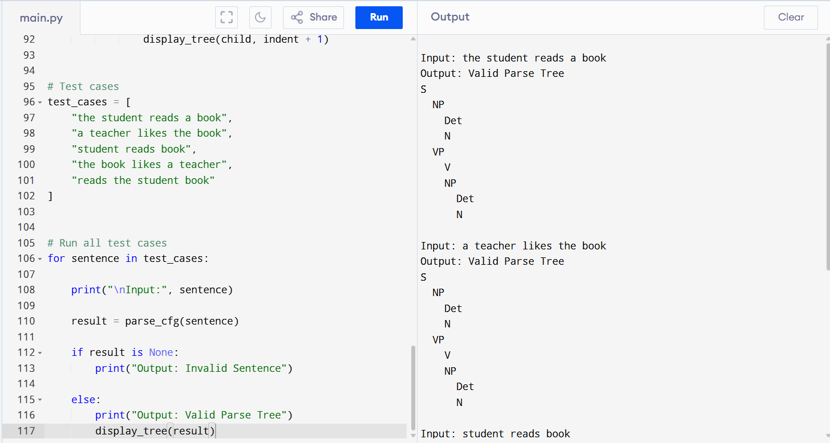

Parse Tree Example
For:
the student reads a book
the structure is:
S
/ \
NP VP
/ \ / \
Det N V NP
| | | / \
the student reads Det N
| |
a book

Result
The Python program successfully validates sentences according to the given CFG and constructs a hierarchical parse tree for valid sentences. Sentences that do not follow the grammar are correctly rejected.
Analysis
The experiment demonstrates that:
- CFG rules can represent sentence structure.
- S → NP VP defines the overall sentence.
- NP → Det N defines noun phrases.
- VP → V NP defines verb phrases.
- Parse trees provide a visual representation of syntactic structure.
- Invalid word order or missing grammatical components results in rejection.

Experiment 2:
Aim
To design a Python program that verifies subject–verb agreement using feature structures containing Number and Person attributes.
Feature Structures
Subjects
Subject | Number | Person
he | Singular | Third
she | Singular | Third
it | Singular | Third
they | Plural | Third
Verbs
Verb | Number
runs | Singular
writes | Singular
run | Plural
write | Plural

Algorithm
- Accept subject and verb as input.
- Create feature structures for subjects.
- Create feature structures for verbs.
- Extract the subject's Number and Person.
- Extract the verb's Number.
- Compare subject Number with verb Number.
- If the numbers match, return True.
- Otherwise, return False.
- Return False if either word is not present in the feature dictionary.
Python code:
# Experiment 2:
# Subject-Verb Agreement using Feature Structures

# Feature structures for subjects
subject_features = {
"he": {
"Number": "singular",
"Person": "third"
},
"she": {
"Number": "singular",
"Person": "third"
},
"it": {
"Number": "singular",
"Person": "third"
},
"they": {
"Number": "plural",
"Person": "third"
}
}

# Feature structures for verbs
verb_features = {
"runs": {
"Number": "singular"
},
"writes": {
"Number": "singular"
},
"run": {
"Number": "plural"
},
"write": {
"Number": "plural"
}
}

def check_agreement(subject, verb):
"""
Checks whether subject and verb agree in Number.
"""

# Convert input to lowercase
subject = subject.lower()
verb = verb.lower()

# Check whether subject and verb exist
if subject not in subject_features:
return False

if verb not in verb_features:
return False

# Extract feature values
subject_number = subject_features[subject]["Number"]
verb_number = verb_features[verb]["Number"]

# Compare Number features
return subject_number == verb_number

# Test cases
test_cases = [
("he", "runs"),
("he", "run"),
("they", "run"),
("they", "writes"),
("she", "writes")
]

for subject, verb in test_cases:
result = check_agreement(subject, verb)

print(
f"Subject: {subject:<5} "
f"Verb: {verb:<7} "
f"Agreement: {result}"
)

OUTPUT:
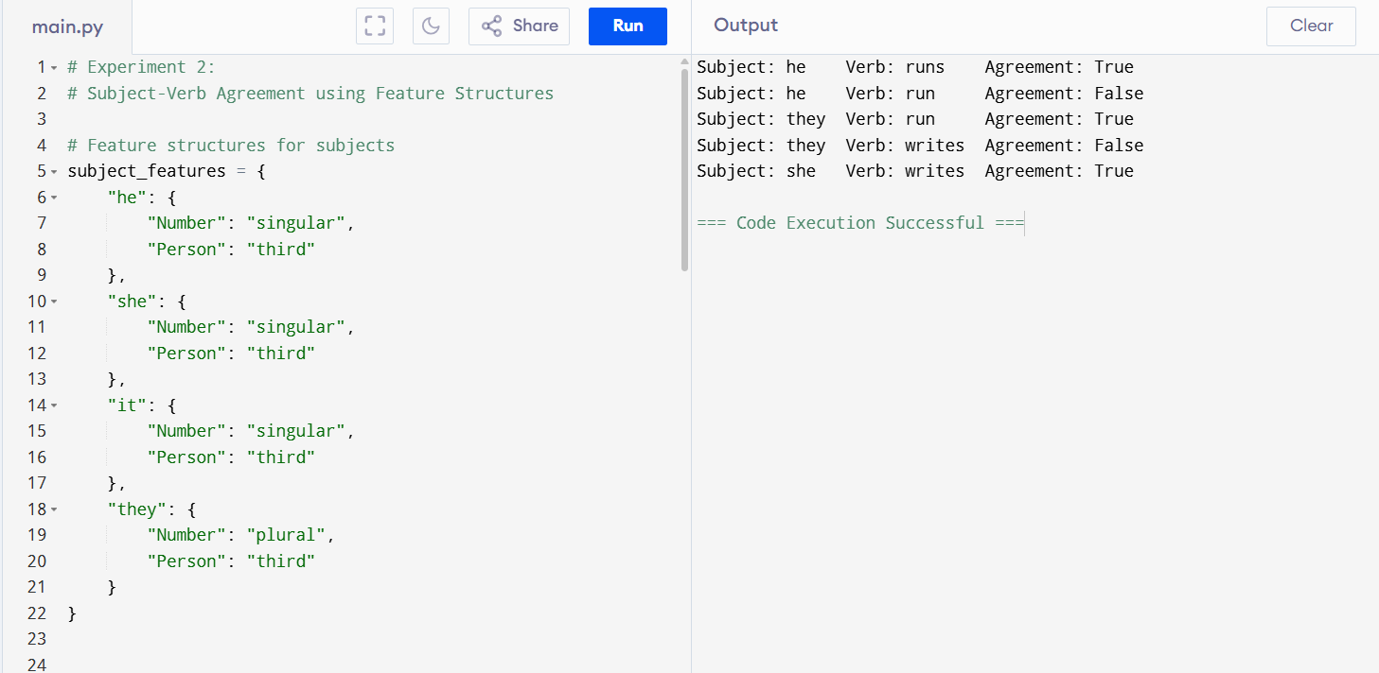

Result
The program successfully verifies subject–verb agreement using feature structures. It returns True when the subject and verb have matching Number features and False otherwise.
Analysis
Feature structures provide a structured way of representing grammatical information.
The experiment demonstrates:
- Number agreement: singular/plural compatibility.
- Person information: subject features include first/second/third person.
- Feature comparison: grammatical compatibility is determined by comparing features.
- Constraint validation: incorrect combinations such as he run are rejected.
This approach can be extended to include additional grammatical features such as Gender, Tense, Case, and Person.

Experiment 3
Aim
To implement a Python program that parses a sentence using a Probabilistic Context-Free Grammar (PCFG) and computes the probability of generating the sentence.

PCFG
Given:
S → NP VP [1.0]

NP → John [0.6]
NP → Mary [0.4]

VP → runs [0.5]
VP → walks [0.5]
The probability of a sentence is:
P(S → NP VP)
× P(NP)
× P(VP)
Therefore:
P(John runs)
= 1.0 × 0.6 × 0.5
= 0.30
P(John walks)
= 1.0 × 0.6 × 0.5
= 0.30
P(Mary runs)
= 1.0 × 0.4 × 0.5
= 0.20
P(Mary walks)
= 1.0 × 0.4 × 0.5
= 0.20
P(Peter runs)
= 0
because Peter is not generated by the grammar.
Algorithm
- Accept a two-word sentence.
- Split the sentence into subject and verb.
- Check whether the subject is generated by the NP rules.
- Check whether the verb is generated by the VP rules.
- Retrieve the probabilities of NP and VP.
- Multiply the probabilities:
P(S) × P(NP) × P(VP)
- Return the calculated sentence probability.
- Return 0.0 if the sentence cannot be generated.
Python Program
# Experiment 3:
# Probabilistic Context-Free Grammar (PCFG) Parsing

# PCFG production probabilities

# S -> NP VP
S_probability = 1.0

# NP production probabilities
NP_probabilities = {
"john": 0.6,
"mary": 0.4
}

# VP production probabilities
VP_probabilities = {
"runs": 0.5,
"walks": 0.5
}

def sentence_probability(sentence):
"""
Computes the probability of a sentence using the PCFG.
Returns 0.0 if the sentence cannot be generated.
"""

# Convert sentence into lowercase words
words = sentence.lower().split()

# Sentence must contain exactly two words
if len(words) != 2:
return 0.0

subject, verb = words

# Check whether subject exists in NP
if subject not in NP_probabilities:
return 0.0

# Check whether verb exists in VP
if verb not in VP_probabilities:
return 0.0

# Retrieve production probabilities
np_probability = NP_probabilities[subject]
vp_probability = VP_probabilities[verb]

# Apply:
# P(S) * P(NP) * P(VP)
probability = (
S_probability
* np_probability
* vp_probability
)

return probability

# Test cases
test_cases = [
"John runs",
"John walks",
"Mary runs",
"Mary walks",
"Peter runs"
]

# Execute test cases
for sentence in test_cases:
probability = sentence_probability(sentence)

print(
f"Input: {sentence:<15} "
f"Probability: {probability:.2f}"
)
OUTPUT:

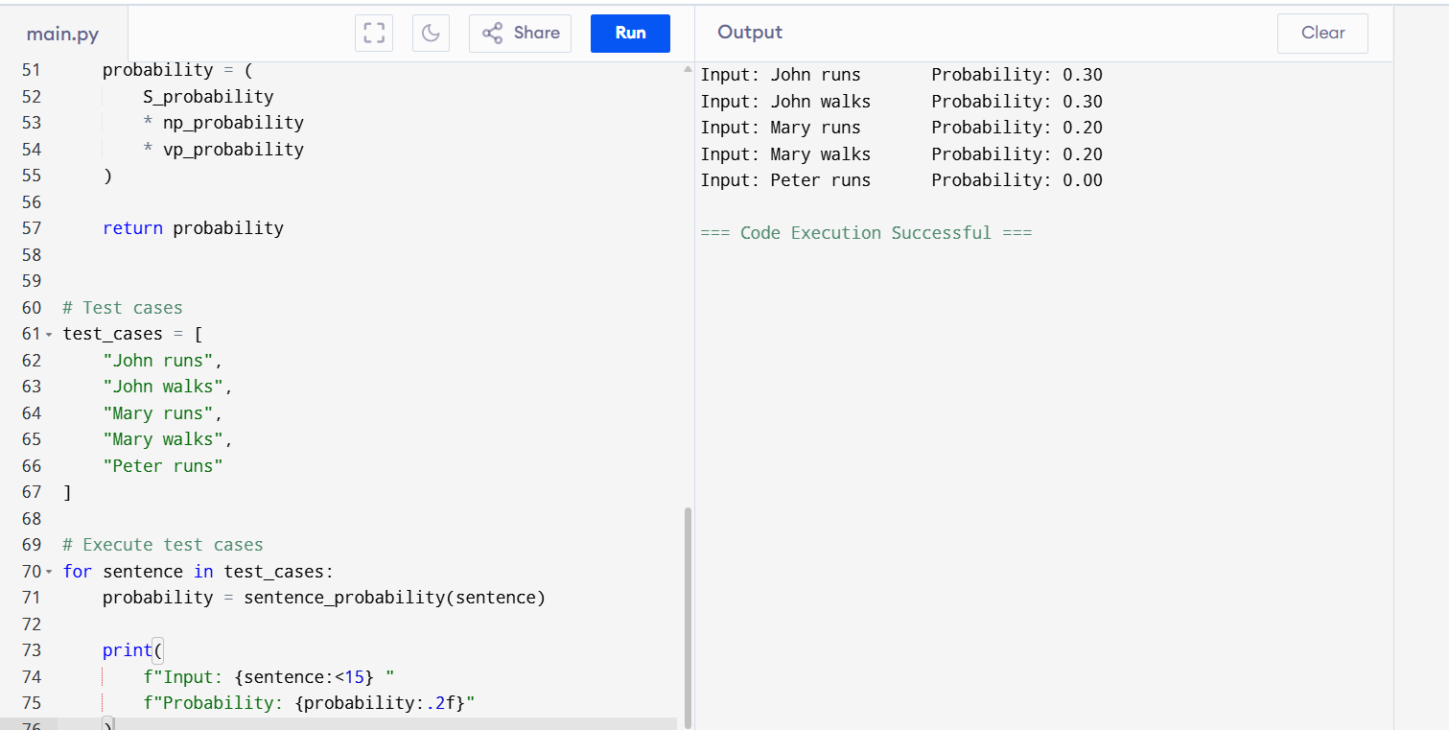
Probability Calculation Table
Sentence | P(S→NP VP) | P(NP) | P(VP) | Final Probability
John runs | 1.0 | 0.6 | 0.5 | 0.30
John walks | 1.0 | 0.6 | 0.5 | 0.30
Mary runs | 1.0 | 0.4 | 0.5 | 0.20
Mary walks | 1.0 | 0.4 | 0.5 | 0.20
Peter runs | 1.0 | 0.0 | 0.5 | 0.00
PCFG Parse Example
For:
John runs
the parse structure is:
S
/ \
NP VP
| |
John runs
Probability:
P(S)
× P(NP → John)
× P(VP → runs)

= 1.0 × 0.6 × 0.5
= 0.30
Result
The program successfully parses two-word sentences using the given PCFG and calculates their probabilities. Sentences containing words not generated by the grammar, such as Peter runs, receive a probability of 0.00.

Rubrics for Calculation

Criteria | Weightage | Level 4 – Exemplary | Level 3 – Proficient | Level 2 – Developing | Level 1 – Beginning
Understanding of Concepts | 25 | Demonstrates thorough understanding and effectively integrates multiple concepts/technologies | Good understanding with proper integration of most concepts | Basic understanding; limited or partial integration | Poor understanding; unable to integrate concepts
Experimental Design | 30 | Well-planned, systematic implementation with optimal solution | Correct implementation with minor issues | Basic implementation with errors or inefficiencies | Incorrect or incomplete implementation
Use of Tools | 20 | Effective and advanced use of tools/technologies with proper configuration | Appropriate use of tools with correct execution | Limited or inconsistent use of tools | Incorrect or minimal use of tools
Analysis of Results | 15 | Insightful analysis with accurate interpretation and validation of results | Good analysis with reasonable interpretation | Basic analysis with limited insights | Poor or incorrect analysis of results
Documentation | 10 | Clear, well-structured documentation with diagrams, code, and results | Organized documentation with necessary details | Basic documentation with missing details | Poor or incomplete documentation

Q. No. / Criteria Level | Understanding of Concepts | Experimental Design | Use of Tools | Analysis of Results | Documentation | Sub. Total | Total %
1
2
3

Faculty In-charge | Course Coordinator | Program Director
Signature: _______________ | Signature: _______________ | Signature: _______________
Date: ___________________ | Date: ___________________ | Date: ___________________

